
Perception of the environment with spatialized sounds

(for blind people)

We have found it possible to perceive spatial features (shape, position, dimensions, etc.) of the surrounding objects when using sounds coming from those objects’ surfaces. We have also verified this fact performing a systematic research with normal-sighted and blind people. Knowing this, we have developed a research device which captures the objects features, and converts them into sounds that are sent on line through headphones in such a way that the subject believes that those sounds come from the objects’ surfaces. This allows the blind user to perceive actual and immediate images of every object in his frontal field, although if there are no sound sources at all. The blind person can turn his head and the objects in front of him will sound as if they were covered by multiple sound sources.

The Laboratory System

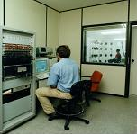
In order to validate the idea and check its viability, in the period 1995-1998 the laboratory system was built and the necessary know-how was obtained. Within a controlled environment and using a very simple depth calculation method based on fixed-sized black circles, and after the personalized measurement of the HRTF set, the system is capable of producing a virtual acoustic space of 17 x 9 x 8 stereopixels covering a distance of up to 4,5 m of the user and a 90º angle.
This system has been successfully tested on more than 20 blind people and is still being used as the basis for the research in psychoacoustic perception. It is based on cameras mounted on spectacles, C80 DSP processors for machine vision and 56002 for sound processing, and finally a pair of headphones worn by the user.

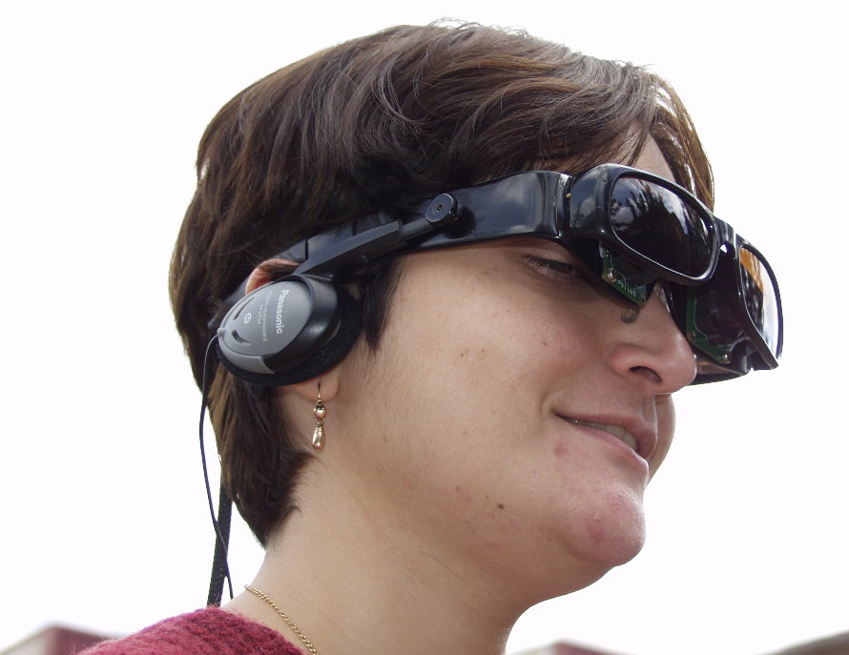
The Portable Prototype

Based on the expertise obtained with the laboratory system, a portable prototype was developed in the period 1998-2002. Spectacles, aesthetically designed, hold a pair of stereo cameras and headphones. A handy PC-like system runs the system, intended to be used for testing during the blind person’s normal life, and then gives feedback to the R+D group with ideas for improvement. A target resolution of 31 x 23 x 16 required the design and development of a HRTF measuring robot. A personalized mannequin, with an acoustical behavior comparable to the user’s one, will be employed during the measuring sessions.

The Commercial System

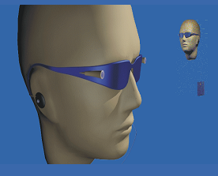

We are working towards a lightweight and portable system to be used daily by the blind. A number of practical needs are to be considered, and also a few improvements like an extended visual field, a better image resolution, more reliable algorithms, faster image rate, more information delivered (color, texture, …). Furthermore this technology could be used also for other purposes such the early stimulation of blind children, computer games for blind users, and other purposes.

Spatialized sounds

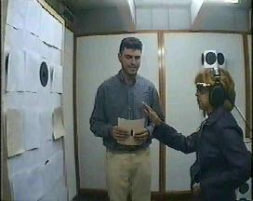
A sound is said to be “spatialized” when it is perceived as coming from somewhere in front of the user, despite it is being reproduced by headphones. The virtual sound generator uses the Head Related Transfer Function (HRTF) technique to spatialize sounds. For each position in space, a set of two HRTFs are needed, one for each ear, so that the interaural time and intensity difference cues, together with the behaviour of the outer ear, are taken into account. In our case, we are using a reverberating environment, so the measured impulse responses would also include information about the echoes in the room. HRTF’s are measured as the responses of miniature microphones (placed in the auditory channel) to a special measurement signal (Maximum Length Sequence). The transfer function of the headphones is also measured in the same way, in order to equalize their contribution.
Having measured these two functions, the HRTF and the Headphone Equalizing Data, properly selected or designed sounds (Dirac deltas) can be filtered and presented to both ears, the same perception being achieved as if the sound sources were placed in the same position from where the HRTF was measured.
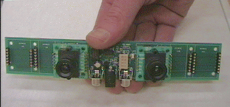

Machine Vision

Passive machine vision has been used for the capture of the surroundings, calculating up to 10 depth maps per second. A couple of video microcameras together with a calibrated stereoscopic disparity algorithm provide an interesting starting point, but additional systems like depth by defocus and others have been explored and will be used to obtain a better set of information to present to the user.

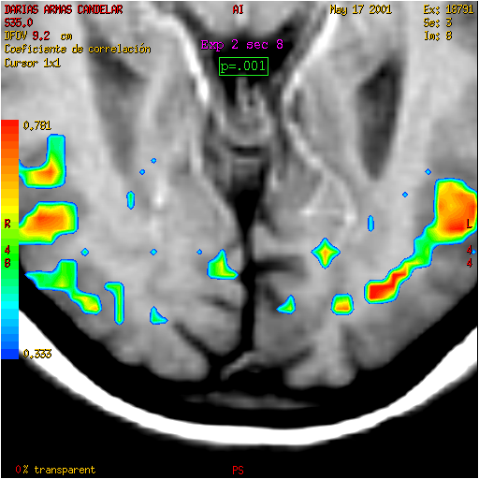
Research with fMRI

Functional Magnetic Resonance Imaging (fMRI) can offer a living imaging of brain functioning when we are talking, thinking, listening...We have used this technology to research into the organization of the brains of blind people when they are listening spatialized sounds (in which their Head Related Transfer Functions –HRTFs- are included). So, we have found how these sounds activate visual areas (besides those of the auditory cortex) in blind people. Furthermore, in a few blind people, these sounds simultaneously evoke visual perceptions (phosphenes).

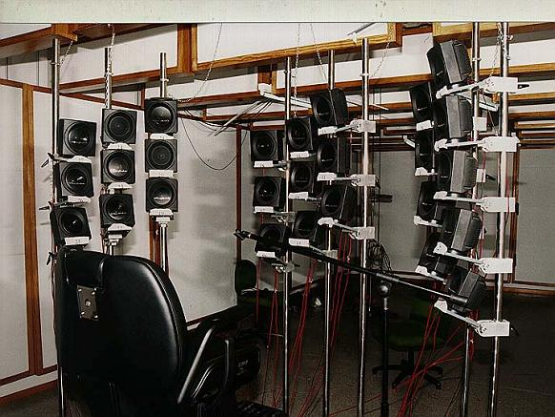

Research on space perception

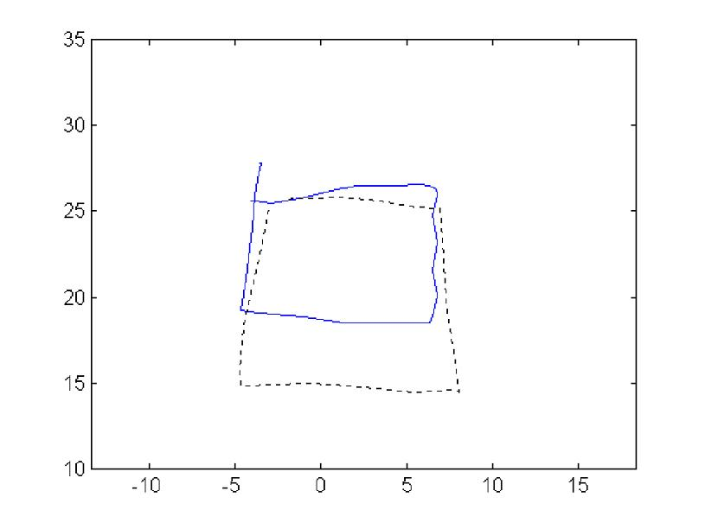
A research line has been opened on the perception of figures using the auditory sense. Using both real sound sources (a loudspeakers wall) and the VAS I system (virtual sound sources) we are studying the effects of changing the acoustic stimulus features and the effects of training and experience on the perception of auditory figures.
Giving attention to the aspect “where the sound is coming from”, subjects, specially blind people, maintain they perceive an image of defined areas of space through which one or more objects seem to be extended, with their shapes, positions and dimensions, globally they feel themselves present inside the perception field and over the time. A drawing of an object perceived from sounds (dotted line), and perceived visually (continuous line), is shown.

  Technology Division  lrr@ll.iac.es | www.iac.es/eav  Canary Islands. SPAIN   | University of La Laguna  jlgonzal@ull.es

